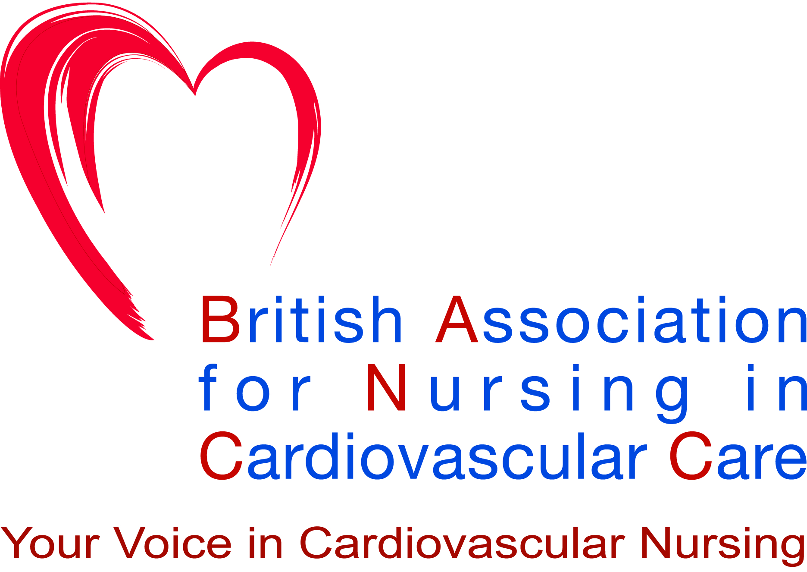

BANCC APPLICATION/RENEWAL MEMBERSHIP FORM
(MEMBERSHIP YEAR – 1 June – 31 May)

The British Association for Nursing in Cardiovascular Care (BANCC) is the ONLY national association for cardiovascular nurses and provides a forum for communication, professional networking and national representation for all nurses in the UK who are involved in the care of cardiovascular patients. The BANCC are affiliated to the British Cardiovascular Society.
-------------------------------------------------------------------------------------------------------------------------------------------------
For a membership fee of £30.00 * per year, members are provided with:

- Free registration place at BANCC Annual Study Day.
- 50% reduction in subscription to the British Journal of Cardiac Nursing.
- A quarterly newsletter and other communications from the Association’s office (e.g. calls for abstracts, notice of courses, conferences, events and other relevant meetings).
- A free subscription to the British Journal of Cardiology.
- Access to the BANCC section of the BCS website.....PLUS MORE!
-------------------------------------------------------------------------------------------------------------------------------------------------
For an additional membership fee of £50.00 per year, BANCC members can become a joint member with the British Cardiovascular Society (BCS). This is available to new and existing BANCC members. Members receive all of the above BANCC only membership benefits plus all of the standard BCS benefits for a total of £80.00 per year including:

- Reduced registration fee to the BCS Annual Conference (£30.00 early bird rate, increasing to £100.00 after early bird deadline).
- Free access to Heart Online & Open Heart Online.
- Constituent Body membership of the European Society of Cardiology (ESC).....PLUS MORE!

For further information on how to apply for the joint BCS membership, please visit: https://www.britishcardiovascularsociety.org/about/membership-benefits.
-------------------------------------------------------------------------------------------------------------------------------------------------

Correspondence Details [PLEASE USE BLOCK CAPITALS]
Title: Surname: Forename:
Current Job Title:
Name of hospital/trust etc:
Address:
Town:
County: Country:
Postcode: Telephone:
Email 1
Email 2
Please submit an email address (plus an alternative email address in case of any communication difficulties) as the majority of communication is sent electronically. To assist BANCC in providing a service that matches your needs please also complete the information on the next page.

Communication

Agenda for change band: ………..............................................................

Professional Qualifications: RN ¨ EN ¨ Other (AHP)……………………………………………………

Post Registration Cardiac course: Level 2 ¨ Level 3 ¨ Level 4 ¨ Please give title: …………………..………
UK Resuscitation Council: ALS Provider ¨ Instructor ¨
Academic Qualifications: Diploma ¨ Degree ¨ MA/MSc ¨ PGCE/DipEd ¨ PhD ¨
Please state if you belong to any other BCS affiliated groups……………………………………………………..

Areas of Professional Interest (Please mark to indicate)

¨ Arrhythmias/ Pacing / Electrophysiology ¨ Paediatric and Adult Congenital Heart Disease
¨ Exercise testing / Chest pain assessment ¨ Emergency Cardiac Care
¨ Research ¨ Nuclear /Magnetic Resonance Imaging
¨ Cardiac Surgery/ Transplantation ¨ Invasive/ Interventional Cardiology
¨ Cardiomyopathy/ Heart Failure ¨ Cardiovascular Pharmacology/ Prescriber
¨ Primary/secondary prevention of Coronary Heart Disease ¨ Stroke
¨ Heart failure / Echocardiography / Valve disease ¨ Other (please state)..........................................
¨ Rehabilitation ..............................................................................

BANCC encourages a direct debit scheme as a means of collecting your annual subscription, so please complete the attached direct debit form and return to BANCC at Fitzroy Square (details below) with your completed application form. We will complete the Reference Number box in the direct debit form. Once returned, we will collect the money from your account on the agreed date (we will advise you of this). These details will remain confidential and will not be passed to any outside agencies. Due to legal reasons, the Direct Debit form has to have the British Cardiovascular Society (BCS) logo and account details on it, but please be assured that the form is indeed for your subscription to BANCC.

Please return this form to: British Association for Nursing in Cardiovascular Care, 9 Fitzroy Square, London W1T 5HW.

I enclose my membership fee *(please indicate):
£30.00 per annum (registered nurses and AHP’s)

£15.00 per annum (students – pre registration)

£35.00 per annum (nurses based overseas)

Communication
Please share your thoughts and suggestions for further development for the role and functions of the BANCC with us. You can contact us at the above address, by email bancc@bcs.com or by phone on
Tel: 020 7380 1919, and all enquiries will be forwarded to the appropriate BANCC representative for action.
Note that by signing this form (unless specified) you agree to the sharing of your data between BANCC and the British Cardiovascular Society, the second organisation of our choice.

SIGNATURE: DATE: _________________

Please note that by joining BANCC you agree to the processing, storage and use of the details you have provided for the purpose of managing your subscription by BANCC and by BCS, who act as Data Processor on behalf of BANCC We will use the details you have shared with us to:
- contact you regarding essential information related to your membership subscription.
- provide you with essential information about the Society’s activities, elections, AGM, events, courses and news.
We will NOT without your consent share your contact details with other individuals or organisations.
We usually contact members by email unless we have not valid address for you, in which case we may contact you by phone or by post. If you wish to unsubscribe from our email list, you may do so at any time by contacting us on bancc@bcs.com or by clicking the link included in our emails; please note that this may prevent you from accessing some or all of the benefits associated with your membership of our Society.

Instruction to your
Bank or Building Society
to pay by Direct Debit
Please fill in the whole form excluding official use box using a ball point pen and send it to: |  |  |  |  |  |  |  |  |  |  |  |  |  |  |  |  |  |  |  | Originator's Identification Number
British Cardiovascular Society  9 Fitzroy Square  London  W1T 5HW |  |  |  |  |  |  |  |  |  |  |  |  |  |  |  |  |  |  |  | 911994 | 1 | 1 | 9 | 9 | 4
FOR British Cardiovascular Society OFFICIAL USE ONLY
This is not part of the instruction to your Bank or Building Society.
Name(s) of Account Holder(s)
Bank/Building Society account number
Branch Sort Code |  |  |  |  |  |  |  |  |  |  |  |  |  |  |  |  |  |  |  | Instruction to your Bank or Building Society  Please pay British Cardiovascular Society Direct Debits from the account detailed in this Instruction subject to the safeguards assured by the Direct Debit Guarantee. I understand that this Instruction may remain with British Cardiovascular Society and, if so, details will be passed electronically to my Bank/Building Society.
Name and full postal address of your Bank or Building Society
To: The Manager |  |  |  |  |  |  |  |  | Bank/Building Society
Address |  |  |  |  |  |  |  |  |  |  |  |  |  |  |  |  |  |  |  | Signature(s)
 |  |  |  |  |  |  |  |  |  | Postcode |  |  |  |  |  |  |  |  |  | Date
Reference Number (to be completed by BANCC)
BANCC
Banks and Building Societies may not accept Direct Debit Instructions from some types of account
DDI1

This guarantee should be detached and retained by the Payer.


The
Direct Debit
Guarantee
- This Guarantee is offered by all banks and building societies that accept instructions to pay Direct Debits.
- If there any changes to the amount, date or frequency of your Direct Debit, BCS will notify you 10 working days in advance of your account being debited or as otherwise agreed. If you request BCS to collect a payment, confirmation of the amount and date will be given to you at the time of the request.
- If an error is made in the payment of your Direct Debit by BCS or your bank or building society, you are entitled to a full and immediate refund of the amount paid from your bank or building society.
- If you receive a refund you are not entitled to, you must pay it back when BCS asks you to.
- You can cancel a Direct Debit at any time by simply contacting your bank or building society. Written confirmation may be required. Please also notify us.

